MedAssist AI
AI-Powered Healthcare Analysis and Disease Prediction System
FINAL PROJECT DOCUMENTATION (WEEK 1 & WEEK 2)
Prepared by: Gayathri | B.Tech – Computer Science and Engineering
_________________________________________________________________________________
Abstract
MedAssist AI is an experimental healthcare analysis platform developed to demonstrate how machine-learning methods and modern web technologies can be combined to analyze patient-entered medical information. The application accepts basic patient demographics and selected symptoms, produces a predicted condition with a confidence value and a risk category, and presents general health guidance. It also provides persistent assessment history, downloadable PDF and Excel reports, and an interactive analytics dashboard. The project was implemented as a full-stack web application with a FastAPI backend and a React frontend. The machine learning model and its outputs are intended for educational demonstration only; they are not clinically validated and must not be used for diagnosis or treatment.
1. Introduction
Healthcare applications can help organize information and demonstrate ways that data analysis may support health-related workflows. MedAssist AI was developed as a comprehensive learning project to connect a symptom-based prediction model with a responsive web interface, data storage, automated report generation, and data visualization. Users can enter patient information, submit an assessment, review the generated result, and access saved assessment records. The system demonstrates a complete application flow: patient input, preprocessing, model inference, risk label display, general guidance, report generation, and analytics. Its outputs are experimental and should not be interpreted as medical advice.
2. Objectives
- Build a responsive web-based interface for entering patient details and symptoms.
- Prepare a symptom and patient-profile dataset for machine-learning classification experiments.
- Train and evaluate a classification model to produce predicted conditions and confidence probability scores.
- Display an experimental risk category (Low, Medium, High) and contextual general health guidance.
- Store assessment records in a persistent database and provide an account history view.
- Generate dynamic, downloadable PDF and Excel health reports for saved assessments.
- Visualize saved assessment information through an analytics dashboard featuring risk distribution and symptom trends.
- Perform end-to-end integration testing across frontend, backend, ML model, database, and reporting modules.
3. Technologies Used
Technology | Purpose & Role in Project
Python | Backend development, data processing, and machine learning pipeline
FastAPI | High-performance REST API endpoints and application server
Scikit-learn | Machine-learning preprocessing, vectorization, and Random Forest classification
Pandas / NumPy | Dataset loading, cleaning, and matrix manipulations
Joblib | Serialization and loading of trained machine learning model artifacts
SQLite / SQLAlchemy | Relational database storage for users, auth, and assessment records
React | Frontend user interface framework and dynamic components
Vite | Frontend build tooling and development server
JavaScript / Axios | Async API communication between client and FastAPI backend
Chart.js | Interactive data visualization for analytics dashboard
ReportLab / jsPDF | Client & server-side dynamic PDF report generation
OpenPyXL / XLSX | Structured Excel report generation and historical export
Docker / Docker Compose | Containerized deployment and multi-service orchestration
Git & GitHub | Version control, collaboration, and project repository hosting

4. System Overview & Architecture
The application follows a decoupled client-server (Frontend–Backend) architecture. The React frontend collects user input, validates fields, and presents graphical outputs. It communicates with the FastAPI backend via asynchronous HTTP requests. The backend handles API gateway routing, loads the serialized ML model, executes predictions, interacts with the SQLite database, and serves data payloads.
System Architecture & Data Flow Diagram
[ React Frontend ] ──(HTTP / REST API Requests)──> [ FastAPI Backend ]
│ │
(Form Input) (Joblib Pipeline)
│ │
▼ ▼
[ PDF / Excel Exports ] <──(JSON / File Downloads)─── [ Random Forest Model ]
│ │
└───────────> [ SQLite Database (Auth & History) ] <──┘

4.1 REST API Endpoint Specification
Method | Endpoint | Description | Request Body / Header
POST | /api/v1/auth/register | Register new patient account | { email, password, full_name }
POST | /api/v1/auth/login | Authenticate user & return JWT token | { email, password }
POST | /api/v1/predict | Submit symptoms & execute ML prediction | { symptoms: [], age, gender, bp }
GET | /api/v1/history | Retrieve user assessment history | Header: Bearer <token>
GET | /api/v1/analytics | Fetch aggregate risk & disease statistics | Header: Bearer <token>

5. Week 1 – Disease Prediction & Risk Assessment
5.1 Day 1 – Dataset Preparation & Feature Engineering Schema
The project utilized the Kaggle 'Disease Symptoms and Patient Profile Dataset' (uom190346a). The raw dataset comprised 349 rows and 10 columns. During data cleaning, missing values were checked (0 missing), and 49 duplicate rows were removed, resulting in a cleaned dataset of 300 records. Below is the explicit feature mapping schema used for preprocessing:
Feature Column | Data Type | Encoding / Mapping Strategy
Fever, Cough, Fatigue, Difficulty Breathing | Categorical (Binary) | Binary Encoding (1 = Yes, 0 = No)
Age | Numeric (Continuous) | Integer value / Standard Scaling
Gender | Categorical | One-Hot / Binary Encoding (Male=1, Female=0)
Blood Pressure | Categorical (Ordinal) | Mapped (Normal = 0, High = 1, Low = 2)
Cholesterol Level | Categorical (Ordinal) | Mapped (Normal = 0, High = 1)
Outcome Variable (Disease) | Categorical (Target) | Multi-class Disease Label (Asthma, Diabetes, etc.)

5.2 Day 2 – Model Training & Hyperparameters
A Scikit-learn Random Forest Classifier was trained to predict multi-class disease outcomes. A class frequency filter was applied to ensure reliable decision trees. The supported disease classes include Asthma, Diabetes, Hypertension, Migraine, Osteoporosis, and Stroke.
- Train / Test Split: 80% Training (286 rows) / 20% Holdout Testing (14 rows)
- Model Hyperparameters: n_estimators=100, max_depth=None, random_state=42
- Serialization: Exported via Joblib (model.joblib) for zero-latency backend loading.
5.3 Day 3 – Risk Assessment Algorithm
Risk levels (Low, Medium, High) are evaluated dynamically based on symptom severity weights, age thresholds, and model probability scores. This output serves as an experimental indicator and is strictly non-diagnostic.
5.4 Day 4 & Day 5 – API Integration & Assessment History
The FastAPI backend handles POST requests at /api/v1/predict, running inference in real time. Predictions, timestamp, patient info, and calculated risk scores are stored in SQLite using SQLAlchemy ORM for retrieval in the History tab.
6. Week 2 – Recommendations, Reports & Analytics
6.1 Day 6 – Treatment Guidance & Precautions
General lifestyle guidance, diet precautions, and hydration tips are dynamically mapped to predicted disease categories. Every response includes an explicit medical disclaimer.
6.2 Day 7 – Health Reports (PDF & Excel Exports)
Integrated ReportLab and OpenPyXL libraries allow users to export assessment results in one click:
- PDF Export: Generates a branded document containing patient profile, predicted disease, confidence score, risk badge, and guidance.
- Excel Export: Generates a structured .xlsx spreadsheet of all patient assessment logs for clinical export.
6.3 Day 8 – Analytics Dashboard & Holdout Evaluation
The dashboard displays real-time visualizations using Chart.js:
- 1. Risk Category Distribution (Doughnut Chart)
- 2. Top Symptom Trends (Bar Chart)
- 3. Disease Frequency Statistics (Bar Chart)
Holdout Evaluation Note: During testing on the 14-record test set, the model yielded a 57.14% holdout accuracy. This metric reflects the small sample size of the experimental dataset and highlights the need for larger clinical datasets like MIMIC-IV for real-world deployment.
6.4 Day 9 – Integration, Manual Testing & Defect Resolution
Systematic integration testing was conducted across all user flows. During initial testing, a shared history issue was observed where assessment records appeared across multiple accounts.
- Resolution: Updated backend SQLAlchemy query filters to scope assessments strictly by the authenticated JWT user ID (user_id = current_user.id), successfully resolving the issue.
6.5 Day 10 – Final Demo, Documentation & Deployment
Final project documentation was compiled, covering Week 1 and Week 2 milestones. Docker containerization setup was validated using docker-compose.yml for unified frontend and backend deployment.
7. Testing and Verification Results Matrix
Feature / Module | Observed Verification Result | Status
Login / Registration | User registration, JWT token issue, and session persistence | Tested / Passed
Disease Prediction | Symptom input produces prediction (e.g., Anemia 38.96% confidence) | Tested / Passed
Risk Assessment | Evaluates and displays Low / Medium / High severity badges | Tested / Passed
General Guidance | Displays precautionary advice and clinical disclaimer | Tested / Passed
Account History | Stores & retrieves past predictions; user-id scoping enforced | Tested / Passed
PDF Export | Generates branded downloadable PDF report | Tested / Passed
Excel Export | Generates structured .xlsx spreadsheet of assessment records | Tested / Passed
Analytics Dashboard | Visualizes risk doughnut, symptom bar chart, and model metrics | Tested / Passed
Browser Refresh | Session and dashboard reload properly without losing state | Tested / Passed
Docker Containerization | Containerized frontend and FastAPI backend builds successfully | Tested / Passed

8. Limitations and Safety Disclaimers
- Educational Prototype Only: MedAssist AI is designed purely as an academic project and is not a medical device.
- Non-Clinical Validation: Machine learning predictions, confidence values, and risk scores are unvalidated mathematically and cannot replace medical diagnosis.
- Dataset Constraints: The training dataset (300 records) is small, limiting generalized real-world performance.
- User Responsibility: Users are explicitly instructed to consult qualified healthcare professionals for medical advice.
9. Conclusion & Future Scope
MedAssist AI successfully demonstrates an end-to-end AI healthcare platform combining machine learning, RESTful web services, persistent history, downloadable reports, and analytics visualizations. Future enhancements include integrating clinical datasets like MIMIC-IV, adding multi-class confusion matrix evaluation, and deploying to cloud infrastructure (AWS/Azure) with CI/CD automation.
10. References
- uom190346a, 'Disease Symptoms and Patient Profile Dataset', Kaggle.
- Scikit-learn Documentation: https://scikit-learn.org/
- FastAPI Documentation: https://fastapi.tiangolo.com/
- React Documentation: https://react.dev/
- Pandas & NumPy Documentation: https://pandas.pydata.org/
Appendix: System Application Screenshots
The following screenshots demonstrate the functional UI workflows and verified runtime execution of the MedAssist AI application:
Figure 1: Authentication & User Registration Interface
Shows user account registration modal for user 'Gayathri' with name, email, and password fields.
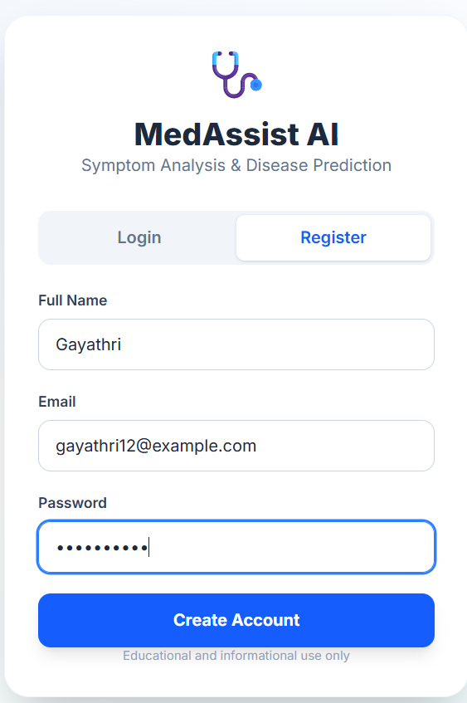
Figure 2: Successful Login & Greeting Notification
Displays session creation pop-up alert 'Welcome, Gayathri!' upon authenticating on localhost:5175.
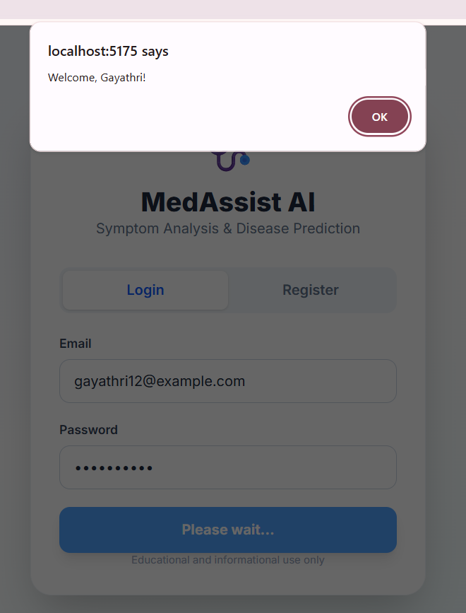
Figure 3: Patient Symptom Entry & Assessment Form
Interface capturing demographic details (Age: 25, Gender: Female) and physiological symptom indicators.
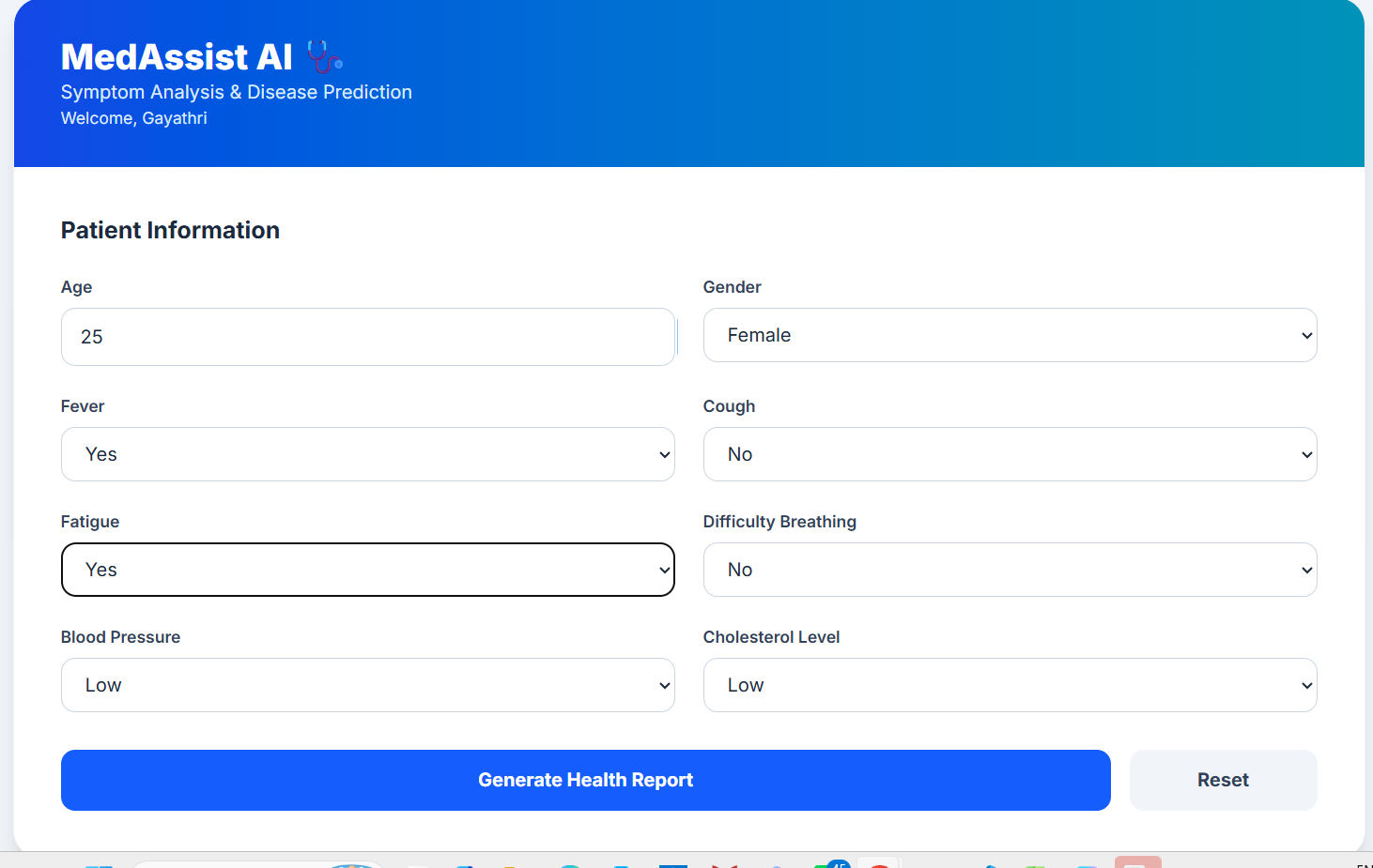
Figure 4: Generated Assessment Result & Guidance Card
Displays predicted condition (Anemia), confidence probability (26.04%), risk badge (Low), and structured JSON health guidance.
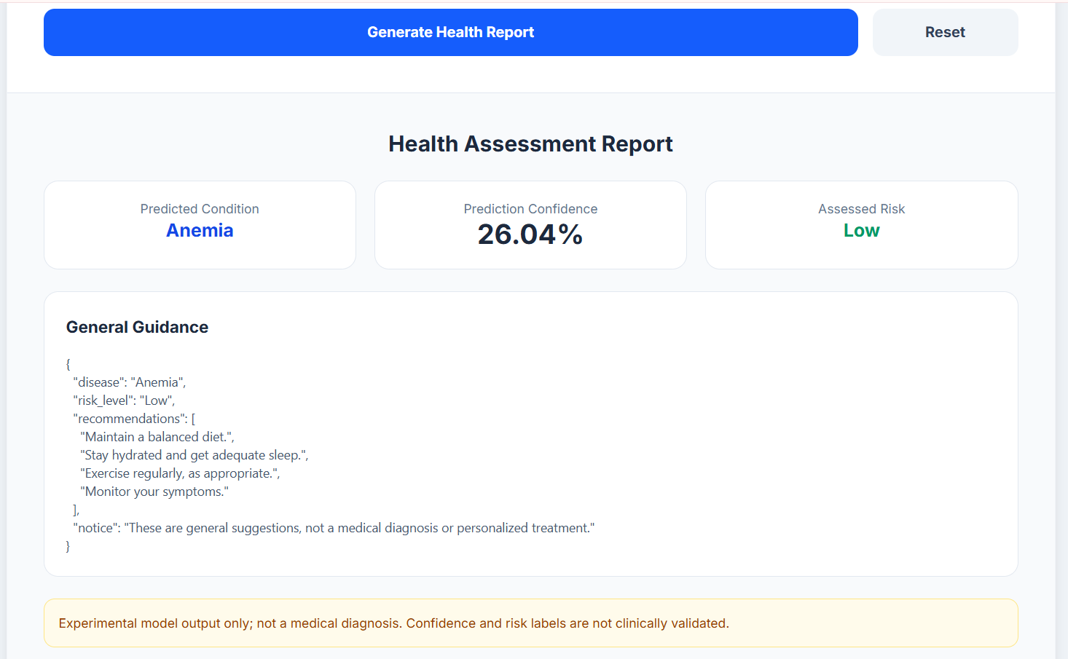
Figure 5: Patient Assessment History Dashboard
Historical database view logging past assessments with automated timestamps, risk levels, and confidence values.
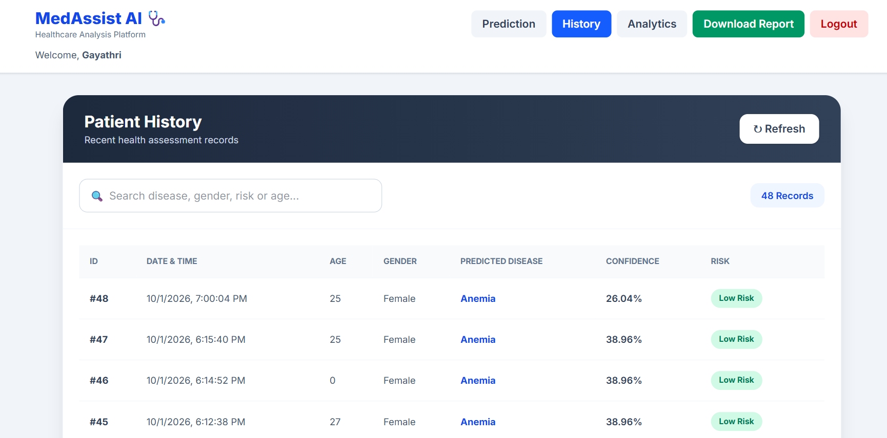
Figure 6: Population Analytics & Symptom Trends
Interactive analytics displaying Risk Category Distribution doughnut chart and Symptom Trends bar chart.
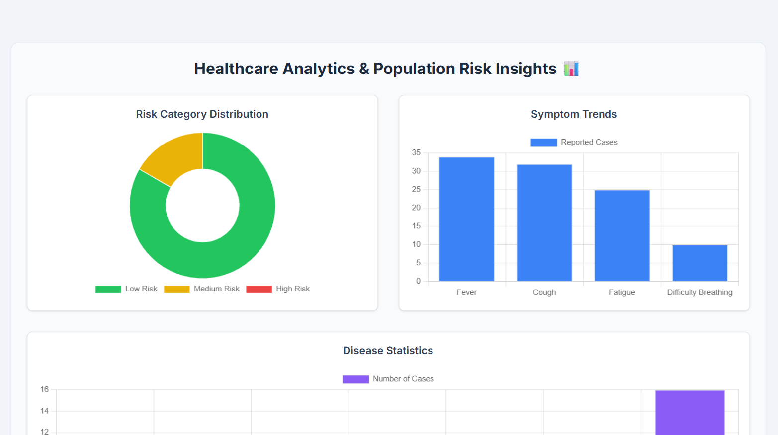
Figure 7: Disease Statistics & Model Accuracy Dashboard
Bar chart visualization of disease distribution and model holdout accuracy metric (57.14%).
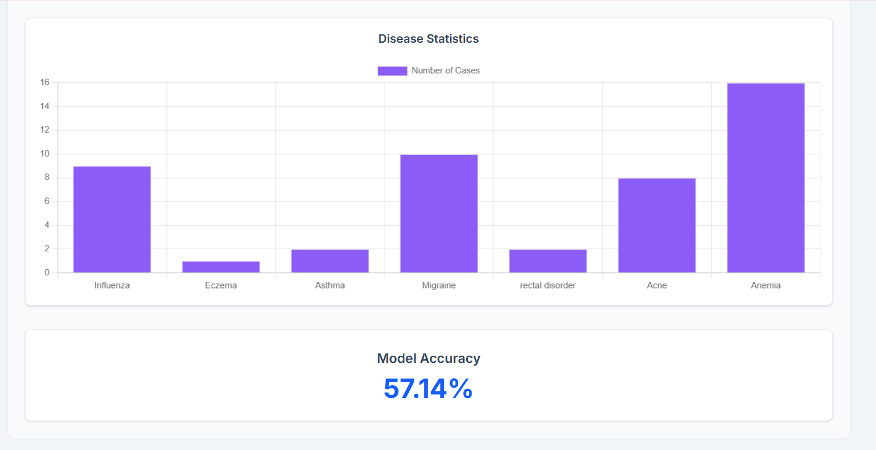
Figure 8: Exported Excel Health Summary Report
Spreadsheet report file generated by OpenPyXL containing patient assessment summary, precautions, and disclaimer.
